SPRINT-2

| **Team ID** | **PNT2022TMID07580** |
| --- | --- |
| **Project** | **IoT Based smart crop protection system for agriculture** |

STEP1: Download and Install NODE JS.

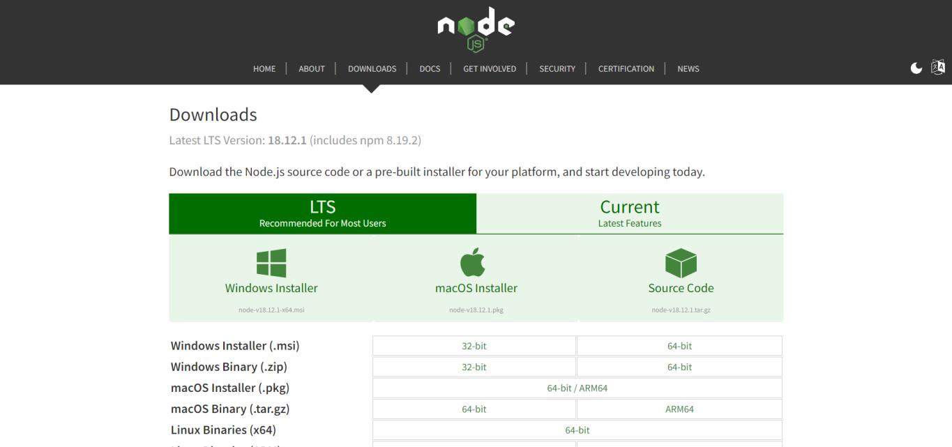

STEP2: Setup node.js and configure command prompt for error check.open node-red from the generated link.

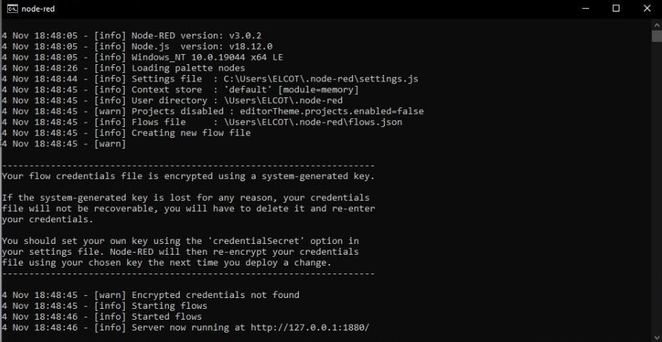

STEP3: Connect IBM IOT in and Debug 1 and Deploy.

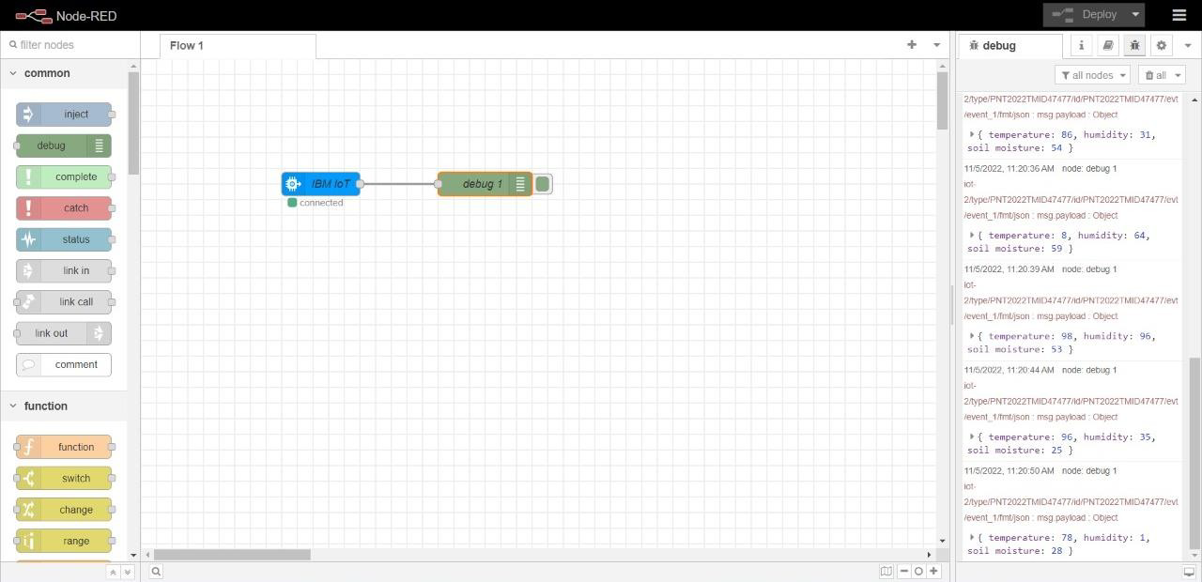

STEP4: Edit gauge node (Here the gauge nodes are named as Temperature, Humidity and Soil moisture).

